USNAAA Southwest Florida Chapter
Officers and Board of Directors

President
CDR Douglas Backes, USN (ret) '70
dougbackes@aol.com

Vice President
Vacant

Secretary
Mr. Herbert John Andrews ‘68
herbiejohn383@gmail.com

Treasurer
Mr. Bailey Geeslin USCGA '60
Vsantbaileygeeslin31@comcast.net

Membership / Web Page Mgr.
Mr. David Finch '67
df121819@aol.com

Chapter Web Site:
http://southwestflorida.usnachapters.net

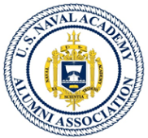

Board Member
Mr. Bruce Needham ‘68
BNeedhamUSNA68@aol.com

Board Member
Vacant

Board Member
MAJ James Neal USMC (ret) ‘60
jjnace@gmail.com
Board Member
CAPT David Dyke USN (ret) '59
dwdyke@att.net

Board Member
Vacant

Board Member
Mr. James Mintun Jr. '59
mintun37@netsync.net

