NOTE: Dates and other details may have changes since letter publication.

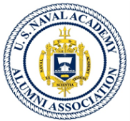
26 October 2017

Fellow Alumni and Members and families of the USNAAA SWF Chapter,
Greetings and Go Navy!
It is my pleasure to take this opportunity to welcome all our Chapter Members on the occasion of the start of our 2017-2018 season. I write this note from our once again sunny but hurricane shocked Southwest Florida area. Many local residents suffered terribly and they are continued to be remembered in our prayers as they truly struggle to get back on their feet.
Despite hurricane Irma damaging some of our member’s homes and destroying many of our trees it did not dampen our enthusiasm for our great Navy football team. We are now looking forward to each game as a reason to get together and cheer on our alma mater and celebrate Navy victories. Our football team is now 5 and 2 with a great win over Air Force and still a contender in conference play.

Speaking of Navy football, I invite all in the area to attend our first luncheon of this season - scheduled for Monday November 13th. Our “kick-off” speaker will be former Navy head coach and local celebrity Mr. Charlie Weatherbie. We are honored to have such a terrific representative of Naval Academy spirit and of the southwest Florida community share his thoughts and inspiration with us.

(A little program change note here: due to tight venue availability, all luncheon events will be at Audubon Country Club and occur on the second MONDAY of the month from November through April; with two planned exceptions, the December luncheon will be our great Navy Tailgate during the Army-Navy game on Saturday 9 December and our last luncheon will be on the first Monday, April 2nd to allow better participation from our snow birds. (However, dates can change to accommodate speakers))

Our second event of the season is our annual Army - Navy game day tailgate to be held at Audubon Country Club in north Naples on Saturday December 9th. We will have a huge screen and sound system, plenty of seating in the large dining room and great food and cheer to watch the Navy Midshipmen take charge and add another win against the Army Black Knights.

Our 2018 winter activities start out with comradery and sharing spirit with members of the Tampa-based Wounded Combat Veterans Challenge invited to speak at our Monday 8 January luncheon and receive our Chapter’s contribution to their great work. (Response TBD)

Speaking of venue challenges – we were hoping to end the month with a resounding smack - as we “drive” to a Navy alumni victory in the 2018 All-Service Academies golf tournament. However, the hurricane put a “duck hook” in our plans to have Navy host at Imperial Golf Club; >>> Hold the presses! UPDATE * UPDATE * UPDATE!!! Today (27 October) Imperial offered to host our event on Tuesday Feb 14th (Valentine’s Day). For now we are in coordination mode with our own team members and the Army and Air Force Alum team Captains>>>. Please contact Jim Mintun or Bruce Needham if you wish to participate or can assist. More details to follow from our co-captains.

Monday February 12 is our annual Valentine’s Luncheon (please bring your spouse/significant other), our scheduled speaker: Author Thomas K. Kimmel, Jr. (grandson of ADM Kimmel, Commander Pacific Fleet of Dec 7 1941 historical perspective). New facts and perspectives on our country’s readiness to repel and leadership actions taken after the Pearl Harbor attack will be revealed.

Nick Paldino has again worked his magic and at our March luncheon (tentatively scheduled for Monday 19 March to accommodate our speaker), we are excited to welcome Mr. Chet Gladchuk, USNA Director of Athletics and 2016 recipient of the John L. Toner Award from the National Football Foundation & College Hall Of Fame. If you remember, Mr. Gladchuk was unable to speak to us last year due to a last minute illness, so we have once again asked him to stop in Naples on his annual recruiting trip through our area. He will give his perspective on the past and future of all Navy sports and athletics programs. Don’t miss this one!

Monday April 2 will be our final luncheon for the 2017 -2018 season (speaker to be invited). Additional events for this season and next season are being solicited from the membership. Our chapter continues to grow with three new member requests over the summer and fall. If you are visiting in the SW Florida area please contact one of our officers and join us at one of our events.

REALITY CHECK: First, I regret to inform those who did not already know that we lost a fellow member this month with the passing of Mr. Roger Rotondi class of 57. Our condolences go out to family and friends. (As per our updated By-Laws, besides seeking out opportunities to support the academy, one of the key responsibilities of membership is to keep eyes and ears open to news or circumstance of our fellow members and pass the word. So If any of you know of another shipmate, or Chapter member, that we’ve lost or needs help or special contact, please let us know through any of our Officers.)
Speaking of Officers, This is a first call for volunteers as new officers/board members needed for 2018-19 season. >>> Note: there is an immediate need for VP candidates to start in January)
We had about sixty members who paid dues for last year and I believe we are up to two new members who have been added to the rolls during the summer hiatus.
And -. Remember - dues are our only source of income for operating expenses! As our past president was fond of saying “ NO DUES >> NO LUNCH!!”
SPEAKERS AND LUNCHEONS: Your Vice President, Dave Dyke, has been very busy off season lining up the venue for our luncheons and the speakers to go with it…however, (having “been there”) I know he is always appreciative of help from our members who have a line to getting great speakers. Specific help is needed for our January luncheon (speakers tentative) and none yet scheduled for the April luncheon.
CALENDAR OF EVENTS:
Our tentative list of events calendar and speakers for this year, so far, are:
- Nov 13 – Luncheon, Speaker: former Navy football coach Charles Weatherbie.
- Late Nov: Bonus local USNA event: Navy B-Ball will be playing in the FGCU Thanksgiving –day tournament event (Homewood Suites Shootout) over the T-Day weekend >> all games at ALICO Arena on campus. Navy plays: 11/24 St Francis - 4:00 PM, 11/25 FGCU - 7:00 PM, 11/26 Denver - 12:00 PM. More details to follow. Thanks go out to Hank White ’68 for the heads-up!!
- Dec 9 – The Great Army-Navy Game Tailgate! enthusiastic cheer leaders and great comradery at Audubon again this year.
- January 8 – Luncheon, Speaker: Combat Wounded Veterans Challenge
- February 12 – Valentine’s Day Luncheon (please bring your spouses), Speaker: Author Thomas K. Kimmel, Jr. (grandson of ADM Kimmel CPF of Dec 7 1941 historical perspective.
- New Date!! February 14 - 8th Annual Service Academy Golf Tournament, Navy is hosting at Imperial Golf Club, 1 pm start. Details coming - from team co-captains; Mr. Bruce Needham and Jim Mintun. This is the ONLY date available at Imperial. Awaiting coordination with Army and Air Force Academy Alums. Players and Help needed!!
- March 19 – Luncheon, Speaker: Mr. Chet Gladchuk, USNA Director of Athletics and 2016 recipient of the John L. Toner Award from the National Football Foundation & College Hall Of Fame.
- April 2 – Luncheon, Speaker: TBD, Final Luncheon for the Season
More information on speakers and venues in 2018 will be coming soon. Please show your support for the Chapter by turning out for these events!

Warmest Regards and BEAT ARMY!!!
Doug Backes
President, USNAAA SWF Chapter
dougbackes@aol.com
cell 301-502-0626

***Attached (last 2 pages) are your slate of Officers for the 2017-2018 Season and an new member application/info update and “Tear off” receipt for annual membership to accompany your dues payment: (please update the requested information) ***

USNAAA Southwest Florida Chapter
Officers and Board of Directors

President
CDR Douglas Backes, USN (ret) '70
Doug & Mary
301-502-0626
dougbackes@aol.com

Vice President
CAPT David Dyke USN (ret) '59
Dave and Betsy
239-231-3575
dwdyke@att.net

Secretary
Mr. Herbert John Andrews ‘68
Herb and Janice
774-280-0359
herbiejohn383@gmail.com

Treasurer
Mr. Bailey Geeslin, USCGA '60
Bailey and Elaine
239-434-6140
bgeeslin725@comcast.net

Membership Data Base Mgr.
Mr. David Finch '67
David & Debbie
774-239-8235
df121819@aol.com

Chaplain – Rev. John Anderson
John and Carey
239-280-8407
ando1154@msn.com

Board Member
Mr. Bruce Needham ‘68
Bruce and Allyson
239-220-6635
BNeedhamUSNA68@aol.com

Board Member
COL Nick Paldino USAF (ret) ‘65
Nick
239-454-7712
npaldino@aol.com
Board Member
MAJ James Neal USMC (ret) ‘60
Jim & Danuta
239-239-821-5165
jjnace@gmail.com
Board Member
RADM Hank White USN (ret) ‘68
Hank and Emmy
312-714-2884
hfwhitejr@aol.com

Board Member
Mr. William Vonier ‘51
Bill & Melita
239-514-4031
bvonier3@gmail.com

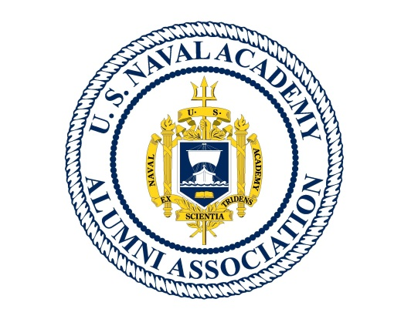
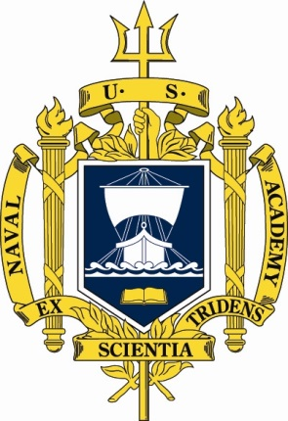

USNAAA SOUTHWEST FLORIDA CHAPTER
MEMBERSHIP FORM

Name: ________________________________________ Class of _______
FL Address: ____________________________________________________________________
([ ]Seasonal or [ ]full time Florida Resident)

Phone Number: ___(_______)_________________________________
Email address ________________________________@________________________
As applicable; Active Duty/ Reserve Service/Retired ______ and last rank ____________________
Requested Status: [ ] Alumni Member, [ ] Associate Member, [ ]Wife, [ ] Widow, [ ] Parent, [ ] Other Academy, [ ] Blue&Gold, [ ]Other- Please Specify_________________________
Annual Dues for 2017-18 season: $30 Amount Enclosed ______________
Mail Form and Check to: USNAAA SWF Treasurer
Mr. Bailey Geeslin USCGA ‘60
725 Courtside Dr Naples, FL 34105

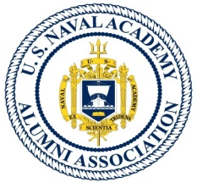
Tear OFF: - - - - - - - - - - - - - - - - - - - - - - - - - - - - - - - - - - - - - - - - - - - - - - - - - - - -- - - - - - - - - - - - - - - - -

Receipt USNAAA SWF Chapter Membership 2017-2018

Paid Annual Dues : $_____ Date ________________

Note: Renewing members please update any new information on the above form and mail in or present it with your payment at our first luncheon.
>>> Remember: dues are our only source of income for operating expenses! As our past president was fond of saying: NO DUES >> NO LUNCH !

