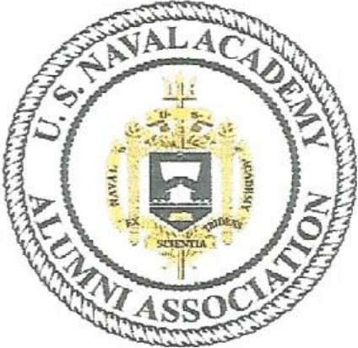

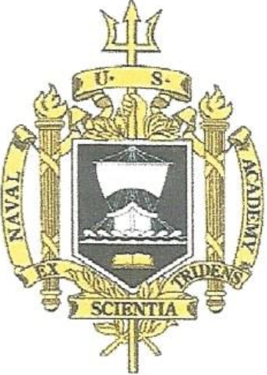

**SOUTHWEST FLORIDA CHAPTER MONDAY NOVEMBER 13, 2017 LUNCHEON**

**1130 SOCIAL HOUR. 1200 LUNCHEON**

**AUDUBON COUNTRY CLUB (US 41 West side between Bonita Beach Road** & **Wiggins Pass Road}, 625 Audubon Blvd, Naples, FL 34110**

**$30- please pay at door. Please reply attendance to Bailey Geeslin:**

**Bgeeslin**[**725@comcast.net**](mailto:725@comcast.net)

***f***

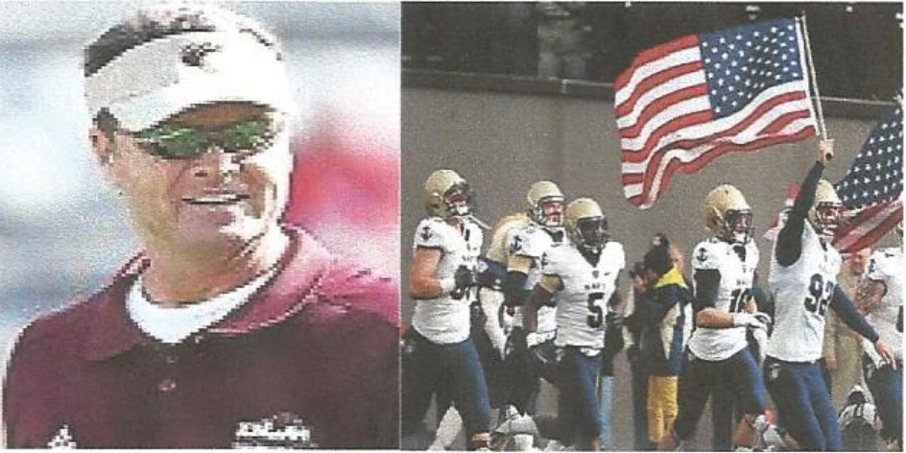

**Our speaker will be former Navy football coach Mr. Charlie Weatherbie.**

**Coach Weatherbie** was a college football coach for 30 years: University of Wyoming (1981-1983) United States Air Force Academy (1984-1989) University of Arkansas (1990-1991) and the last 17 years as a head coach, Utah State University for 3 seasons (1992-1994), 7 seasons as head coach at the United States Naval Academy (1995-2001), 7 seasons at University of Louisiana Monroe (2003-2009). In April he became the Public relations Ambassador, Director of the Hope Project and Area Director of marketing and promotions for Promise Keepers in Central FL, at First Baptist Church Orlando, FL (2010). He has been the Director of Love Orlando (Local Missions) at First Baptist Church Orlando, FL (2011-present).

**11/13/171unch**

**Salad, stuffed chicken, cheese** & **ham, peppers** & **broccoli, sweet potato puree, pumpkin pie, lemon chocolate chip quenelle.**